1580 Ausberg Gorget Pattern
Pattern from John Cope, traced from the original in the collection of Wade Allen (A201) http://allenantiques.com/A-201.html
Assembly instructions can be found at http://borealissteel.ca/1560-ausberg-gorget-construction-notes
Build thread can be found on the Armour Archive here: http://forums.armourarchive.org/phpBB3/viewtopic.php?f=1&t=157286
Permission granted to use, refine or reproduce this pattern.
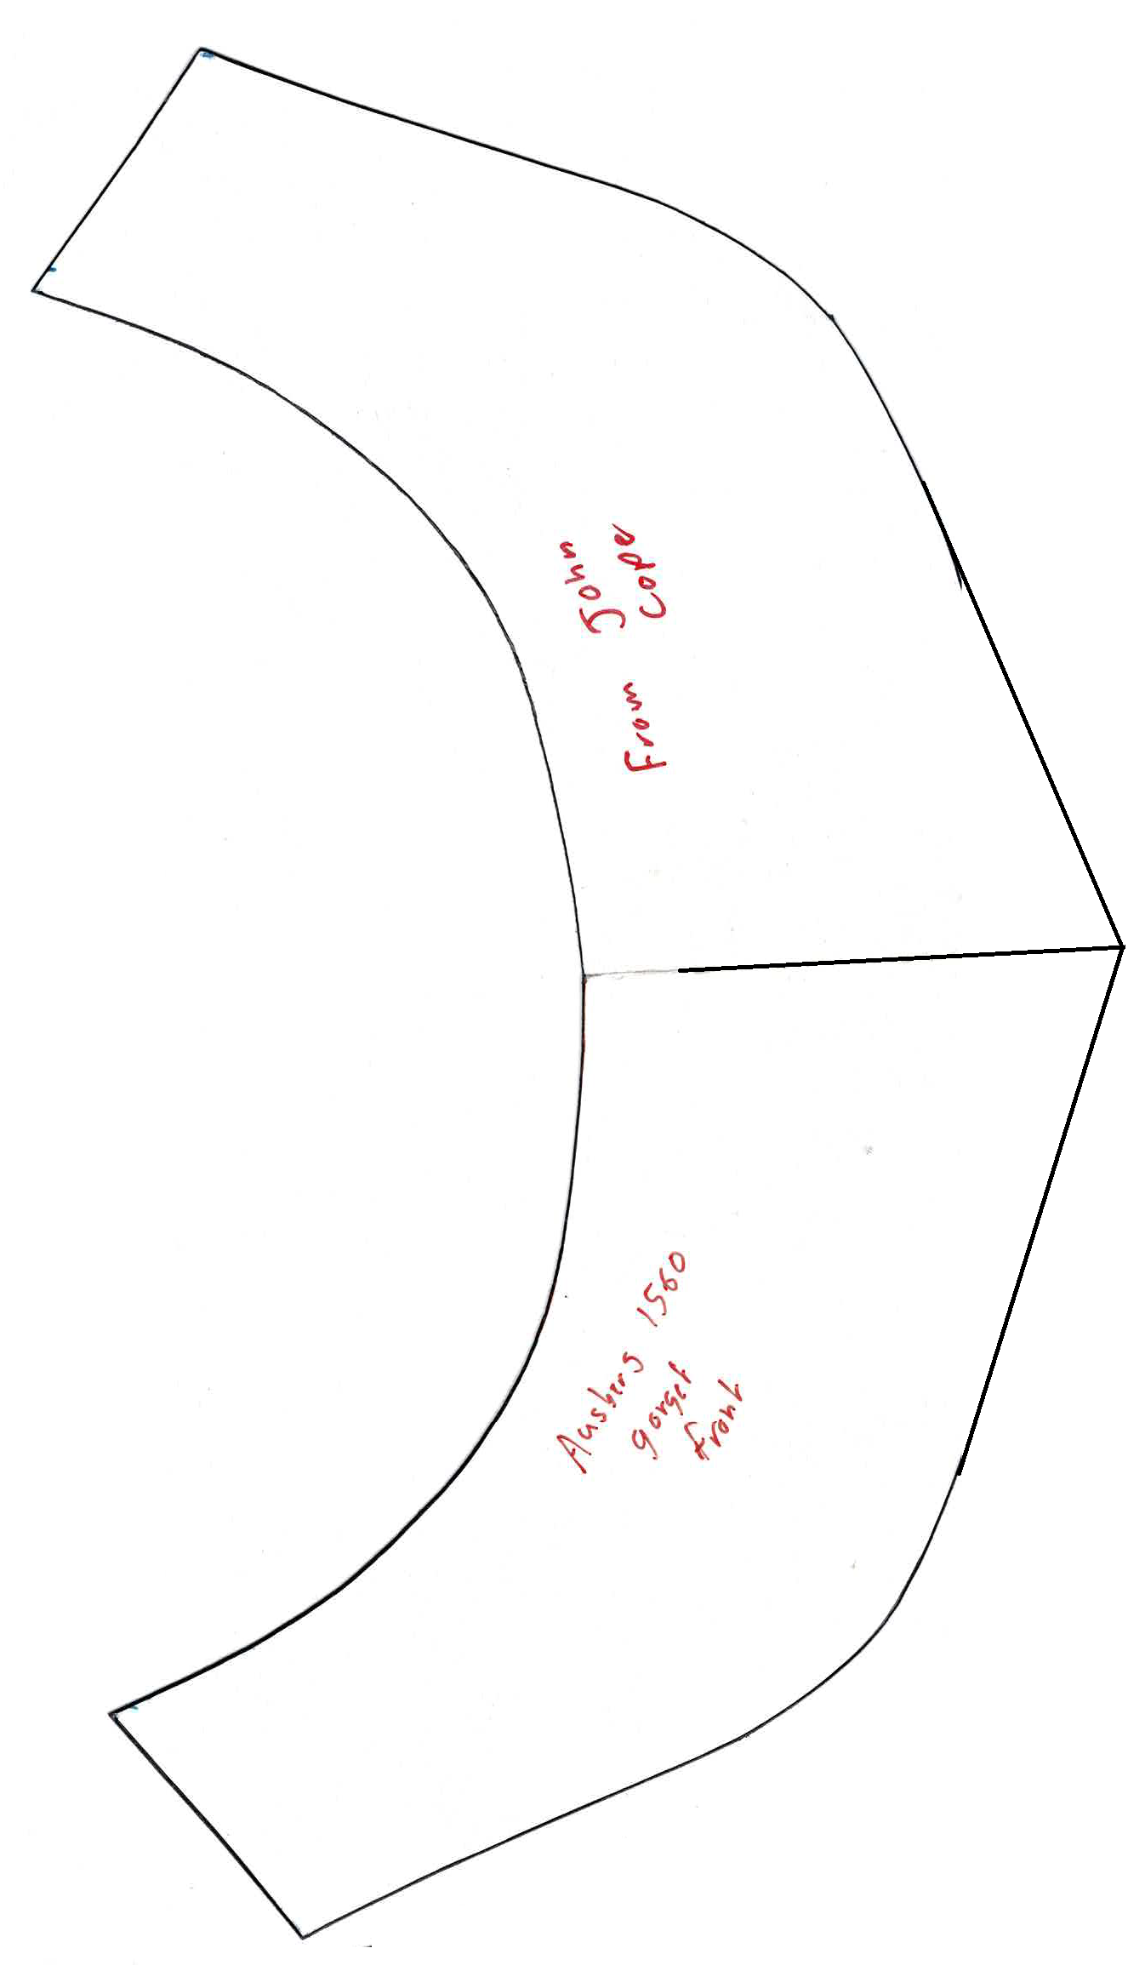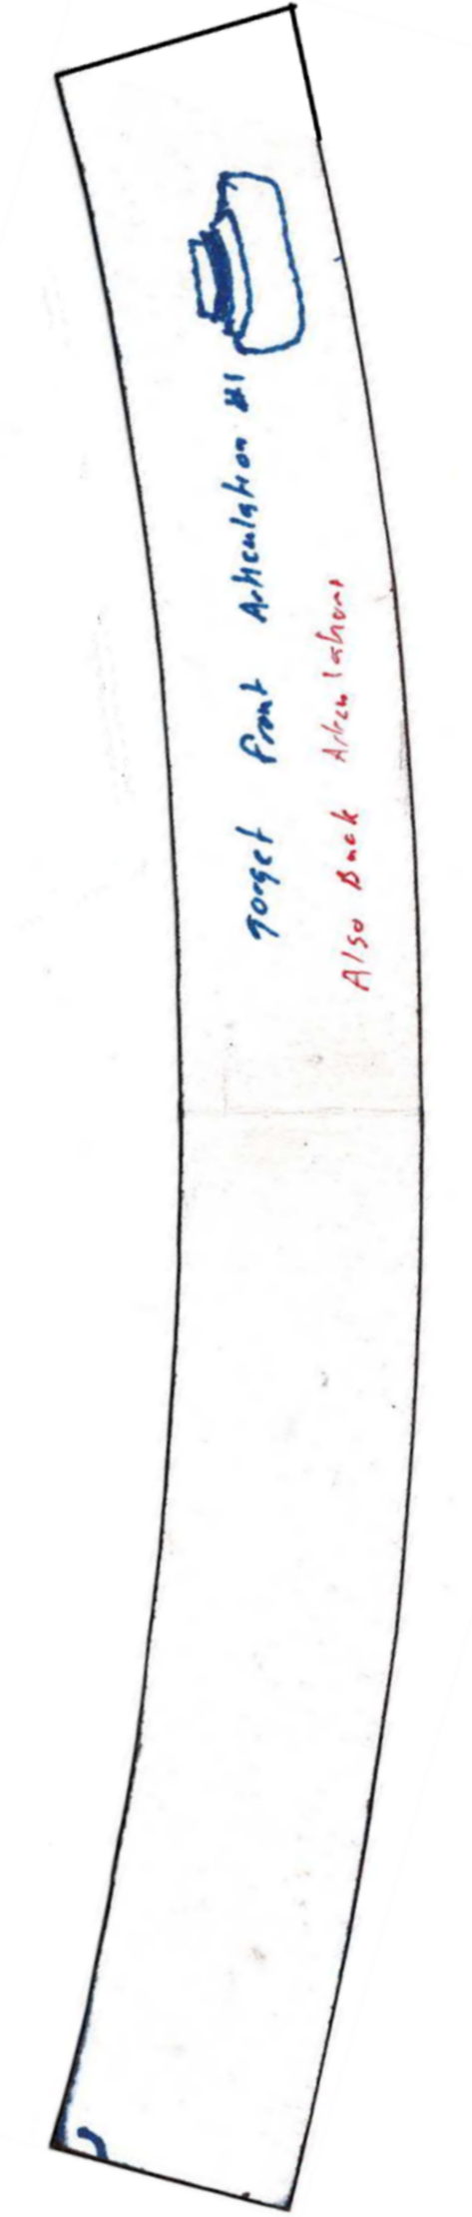

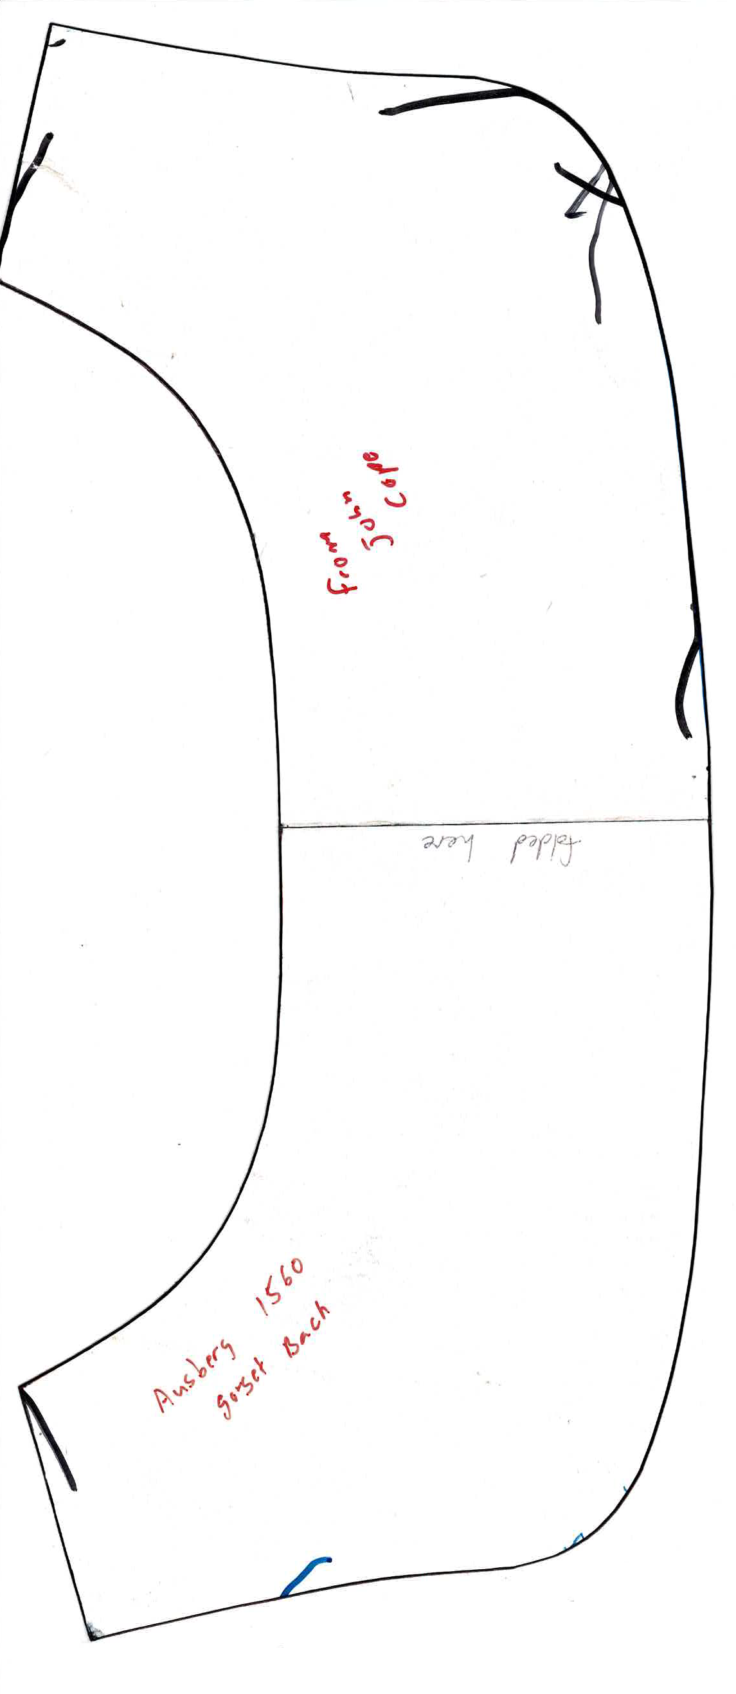

Permission granted to use, refine or reproduce this pattern.

